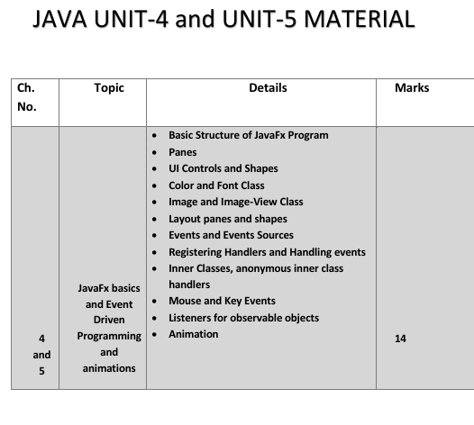

✅ What is JavaFX?
JavaFX is a Java library used to create GUI (Graphical User Interface) applications.
👉 In simple words:
It helps you make apps with buttons, windows, graphics, animations, and media.
✔ It is used to:
- Design UI (user interface)
- Create graphics applications
- Build modern desktop apps
✔ It works on different platforms (Windows, Mac, Linux)

✅ Basic Structure of JavaFX Program
JavaFX mainly has 3 important parts:
👉 Stage, Scene, Node

1) Stage (Window)
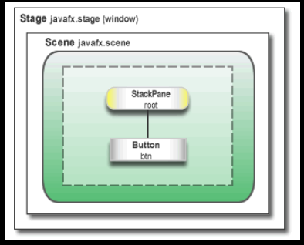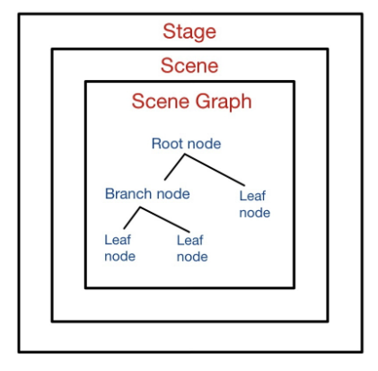
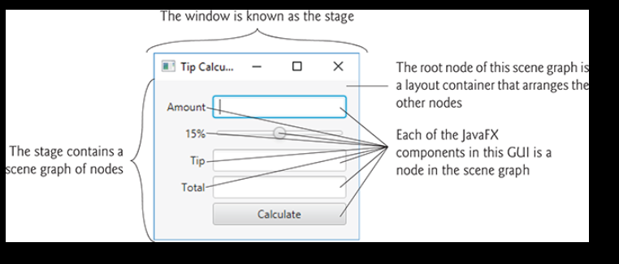
✔ Stage is like a window of the application
✔ It is the main container that holds everything
👉 Important points:
- Created automatically by JavaFX
- Passed to start() method
- Comes from javafx.stage.Stage package
- Divided into:
  - Content area
  - Border
- To display it → use show()

2) Scene (Content Area)
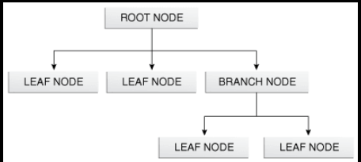

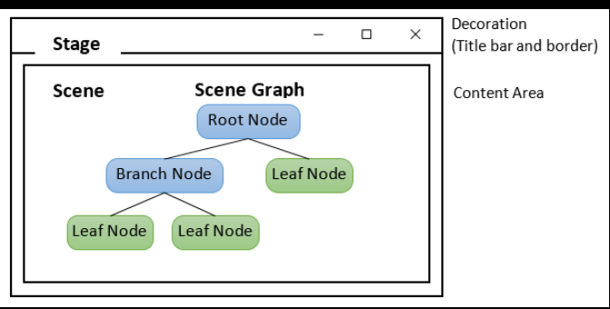
✔ Scene is the content inside the window
👉 Simple understanding:
Stage = Window
Scene = What is inside the window
👉 Important points:
- Contains all UI elements (buttons, text, etc.)
- Represented by javafx.scene.Scene
- One scene → only one stage at a time
- Created using new Scene()

3) Node (UI Elements)
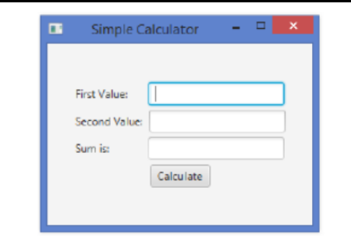

✔ Node means UI components
👉 Examples:
- Button
- TextField
- Label
👉 Simple understanding:
Node = Small elements inside Scene

✅ Important Methods in JavaFX
1) start()
✔ Main method of JavaFX
✔ All code is written here
✔ Called automatically

2) init()
✔ Empty method (optional)
✔ Used for initialization
❌ Cannot create Stage or Scene here

3) stop()
✔ Called when application closes
✔ Used to stop or clean resources

4) launch()
✔ Used to start JavaFX application
✔ It is static method
✔ Called inside main() method

✅ Important Rule
👉 Every JavaFX class must extend:
javafx.application.Application

✅ Example Program (Corrected + Simple)

import javafx.application.Application;
import javafx.scene.Scene;
import javafx.stage.Stage;
import javafx.scene.control.Button;

public class A extends Application
{
public void start(Stage ps)
{
Button b = new Button("OK");

Scene s = new Scene(b, 200, 250);

ps.setTitle("My First Program");
ps.setScene(s);
ps.show();
}

public static void main(String[] args)
{
launch(args);
}

}

🧠 Final Memory Trick (Very Easy)
👉 Remember like this:
- Stage = Window
- Scene = Content
- Node = Items (Button, Text)
👉 Flow:
Application → Stage → Scene → Node

Q-2 Explain panes in JavaFx
Ans:
👉 A pane is a UI element ("Node") that contains other UI elements ("child nodes") and manages the layout of those nodes within the Pane.
👉 Following are the types of pane in JavaFx class
o Flow Pane
o Stack Pane
o Border Pane
o Grid Pane
o Tile Pane
o Anchor Pane
o V-Box
o H-Box

✅ 1) Flow Pane
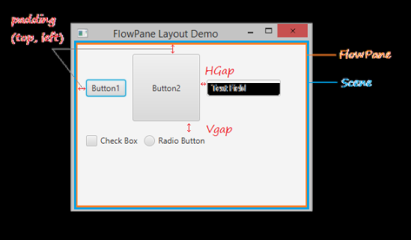
🔹 Point
Flow Pane lays all nodes one after another in the order they were added
🔹 Simple Explanation
It puts items one by one in a line (left to right)
🔹 Meaning
Items follow a flow (line)
If space ends → go to next line
🔹 Example
Like people standing in a queue
import javafx.application.Application;
import javafx.scene.Scene;
import javafx.stage.Stage;
import javafx.scene.control.Button;
import javafx.scene.layout.FlowPane;

public class A extends Application
{
public void start(Stage ps)
{
FlowPane p = new FlowPane();

Button b1 = new Button("Ok");
Button b2 = new Button("Cancel");

p.getChildren().addAll(b2, b1);

Scene s = new Scene(p, 200, 250);
ps.setTitle("Flow layout");
ps.setScene(s);
ps.show();
}

public static void main(String[] args)
{
launch(args);
}
}

🧠 Memory Trick
👉 Flow = Line → → → ↓

2) Stack Pane :-
🔹 Point
Stack Pane lays all nodes one on top of another
🔹 Simple Explanation
Items are placed over each other
🔹 Meaning
Last item = top visible
🔹 Example
Like stack of books
import javafx.application.Application;
import javafx.scene.Scene;
import javafx.stage.Stage;
import javafx.scene.control.Button;
import javafx.scene.layout.StackPane;

public class A extends Application
{
public void start(Stage ps)
{
StackPane p = new StackPane();

Button b1 = new Button("Ok");
Button b2 = new Button("Cancel");

p.getChildren().addAll(b2, b1);

Scene s = new Scene(p, 200, 250);
ps.setTitle("Stack layout");
ps.setScene(s);
ps.show();
}

public static void main(String[] args)
{
launch(args);
}
}

3) Grid Pane :-
🔹 Point
Grid Pane creates rows and columns and places items exactly
✔ You can place elements at exact position
🔹 Simple Explanation
It works like a table
🔹 Meaning
You control position using row + column
🔹 Example
Like Excel sheet
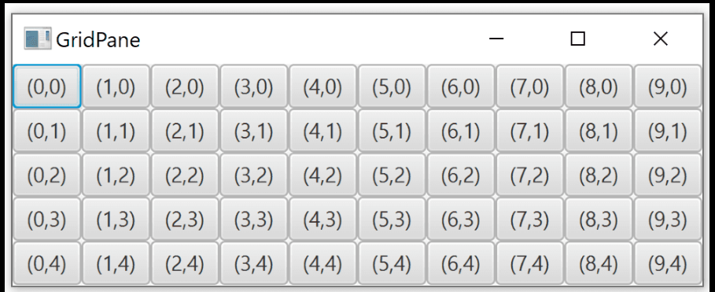

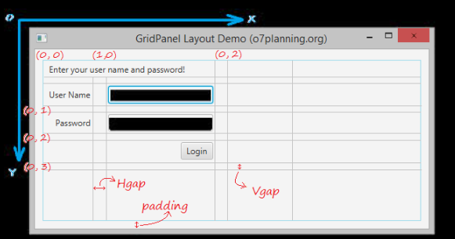
package JavaFx;
import javafx.application.Application;
import javafx.scene.Scene;
import javafx.stage.Stage;
import javafx.scene.control.*;
import javafx.scene.layout.GridPane;
public class vinay_7_sample extends Application
{
@Override
public void start(Stage primaryStage)
{
Label l1 = new Label("Username");
Label l2 = new Label("Password");
TextField t1 = new TextField();
TextField t2 = new TextField();
Button b = new Button("Submit");
GridPane g = new GridPane();
g.addRow(0, l1, t1);
g.addRow(1, l2, t2);
g.addRow(0, b);
Scene s = new Scene(g, 200, 250);
primaryStage.setTitle("Grid Layout");
primaryStage.setScene(s);
primaryStage.show();
}
public static void main(String[] args)
{
launch(args);
}
}

Output:
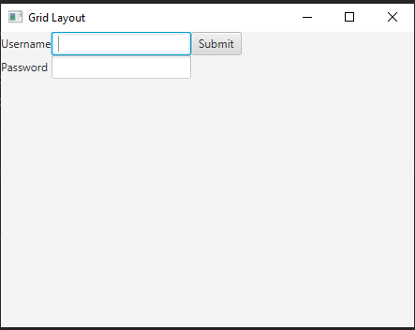
🧠 Memory Trick
👉 Grid = Table (rows + columns)

4) Border Pane
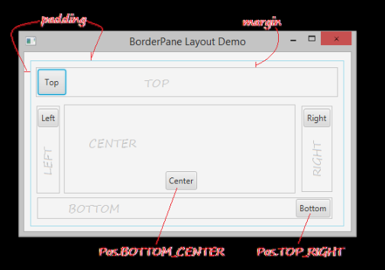
✔ BorderPane divides screen into 5 parts:
- Top
- Bottom
- Left
- Right
- Center
👉 You can add different nodes in each area

✔ Correct Example:
import javafx.application.Application;
import javafx.scene.Scene;
import javafx.stage.Stage;
import javafx.scene.control.Button;
import javafx.scene.layout.BorderPane;

public class A extends Application
{
public void start(Stage ps)
{
Button b1 = new Button("Left Button");
Button b2 = new Button("Right Button");
Button b3 = new Button("Top Button");
Button b4 = new Button("Bottom Button");
Button b5 = new Button("Center Button");

BorderPane bp = new BorderPane();

bp.setLeft(b1);
bp.setRight(b2);
bp.setTop(b3);
bp.setBottom(b4);
bp.setCenter(b5);

Scene s1 = new Scene(bp, 200, 250);
ps.setScene(s1);
ps.show();
}

public static void main(String[] args)
{
launch(args);
}
}

5) Anchor Pane:
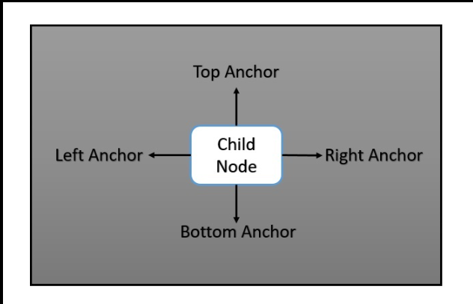
✔ AnchorPane allows you to fix position using distance (pixels)
✔ 4 anchors:
- Top
- Bottom
- Left
- Right
👉 You set distance from edges

✔ Correct Example:
import javafx.application.Application;
import javafx.scene.Scene;
import javafx.stage.Stage;
import javafx.scene.control.*;
import javafx.scene.layout.AnchorPane;
public class vinay_7_s extends Application
{
public void start(Stage ps)
{
Button b = new Button("Ok");
TextArea t = new TextArea();
AnchorPane a = new AnchorPane();
a.getChildren().addAll(t, b);
AnchorPane.setTopAnchor(t, 10.0);
AnchorPane.setBottomAnchor(t, 10.0);
AnchorPane.setLeftAnchor(t, 10.0);
AnchorPane.setRightAnchor(t, 10.0);
AnchorPane.setTopAnchor(b, 20.0);
AnchorPane.setLeftAnchor(b, 20.0);
Scene s1 = new Scene(a, 200, 250);
ps.setScene(s1);
ps.show();
}
public static void main(String[] args)
{
launch(args);
}
}
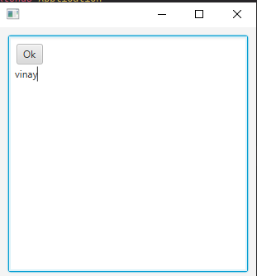
Output:-

6) Tile Pane:
✔ Similar to FlowPane
✔ Arranges in rows
✔ Moves to next line when full
🔥 Difference:
- FlowPane → different sizes
- TilePane → same size cells
- ✔ Correct Example:
import javafx.application.Application;
import javafx.scene.Scene;
import javafx.stage.Stage;
import javafx.scene.control.Button;
import javafx.scene.layout.TilePane;
public class A extends Application
{
public void start(Stage ps)
{
Button b1 = new Button("Ok");
Button b2 = new Button("Cancel");
Button b3 = new Button("Retry");
Button b4 = new Button("Hide");
Button b5 = new Button("HHH");
b1.setMaxSize(Double.MAX_VALUE, Double.MAX_VALUE);
b2.setMaxSize(Double.MAX_VALUE, Double.MAX_VALUE);
b3.setMaxSize(Double.MAX_VALUE, Double.MAX_VALUE);
b4.setMaxSize(Double.MAX_VALUE, Double.MAX_VALUE);
b5.setMaxSize(Double.MAX_VALUE, Double.MAX_VALUE);
TilePane t = new TilePane();
t.getChildren().addAll(b1, b2, b3, b4, b5);
Scene s1 = new Scene(t, 200, 250);
ps.setScene(s1);
ps.show();
}
public static void main(String[] args)
{
launch(args);
}
}

7 - 8) HBox vs VBox (JavaFX Layout)
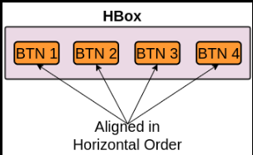
🔹 HBox
✔ HBox means Horizontal Box
👉 It arranges items in one row (left → right)
✔ All elements are placed side by side
👉 Example:
- Button1 | Button2 | Button3
👉 Simple:
HBox = horizontal (side by side)

✔ Features:
- Layout direction → Horizontal
- Items go in single row
- Can set spacing between items

✅ Example:
import javafx.application.Application;
import javafx.stage.Stage;
import javafx.scene.Scene;
import javafx.scene.layout.HBox;
import javafx.scene.control.Button;
public class A extends Application
{
public void start(Stage s)
{
Button b1 = new Button("One");
Button b2 = new Button("Two");
Button b3 = new Button("Three");
HBox h = new HBox(10); // spacing = 10
h.getChildren().addAll(b1, b2, b3);
Scene sc = new Scene(h, 200, 250);
s.setScene(sc);
s.show();
}
}

🔹 VBox
✔ VBox means Vertical Box
👉 It arranges items in one column (top → bottom)
✔ All elements are placed one below another
👉 Example:
- Button1
- Button2
- Button3
👉 Simple:
VBox = vertical (up-down)
✔ Features:
- Layout direction → Vertical
- Items go in single column
- Can set spacing between items

✅ Example:
import javafx.application.Application;
import javafx.stage.Stage;
import javafx.scene.Scene;
import javafx.scene.layout.VBox;
import javafx.scene.control.Button;
public class A extends Application
{
public void start(Stage s)
{
Button b1 = new Button("One");
Button b2 = new Button("Two");
Button b3 = new Button("Three");
VBox v = new VBox(10); // spacing = 10
v.getChildren().addAll(b1, b2, b3);
Scene sc = new Scene(v, 200, 250);
s.setScene(sc);
s.show();
}
}

🧠 Final Quick Revision Trick
Pane | Meaning
FlowPane | Line by line
StackPane | On top
GridPane | Table
BorderPane | 5 parts
AnchorPane | Fix position
TilePane | Same size grid
Note :- Anchor Pane code is very hard to understand
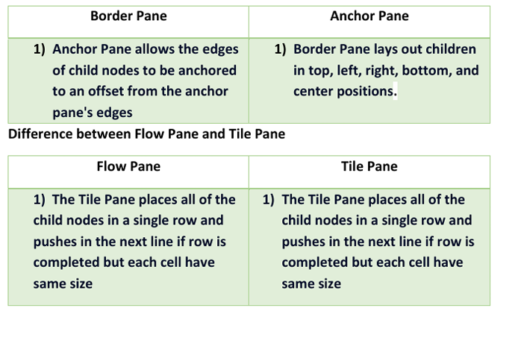
BorderPane | AnchorPane
Layout in 5 areas | Fix position using edges
Top, Bottom, Left, Right, Center | Set distance from edges
Structured layout | Flexible positioning
FlowPane | TilePane
Items flow in rows | Items arranged in grid
Moves to next line automatically | Fixed rows & columns
Different sizes allowed | Same size for all

HBox | VBox
Horizontal layout | Vertical layout
Left → Right | Top → Bottom
One row | One column
Side by side items | One below another

🧠 FINAL MEMORY TRICK
👉 HBox = H = Horizontal
👉 VBox = V = Vertical

🔥 One-Line Answer (Exam)
👉 HBox arranges nodes horizontally, while VBox arranges nodes vertically.
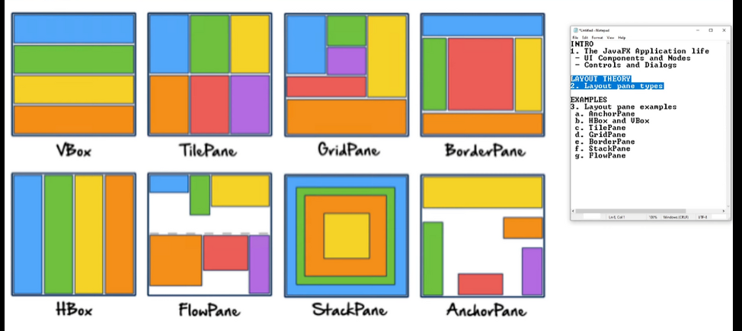

Q-3 Explain UI controls and shapes
Ans:
UI Controls:
👉 UI Controls = Elements used to interact with user
Examples: Button, TextField, Label, etc.
✔ Label is used to display text only
❌ User cannot edit it
import javafx.application.Application;
import javafx.stage.Stage;
import javafx.scene.Scene;
import javafx.scene.control.Label;
import javafx.scene.layout.FlowPane;
public class A extends Application
{
public void start(Stage s)
{
Label l = new Label("Hello");
FlowPane f = new FlowPane();
f.getChildren().addAll(l);
Scene s1 = new Scene(f, 200, 250);
s.setScene(s1);
s.show();
}
}
2) Labeled
✔ Labeled is a parent class (abstract class)
👉 It is used by:
- Label
- Button
- CheckBox
- RadioButton
✔ These controls can show:
- Text
- Image (graphics)
👉 Simple:
Labeled = Parent → Label, Button etc. are children

3) Button:
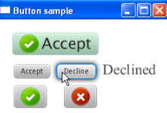
✔ Button is used to perform action when clicked
✅ Example:
import javafx.application.Application;
import javafx.stage.Stage;
import javafx.scene.Scene;
import javafx.scene.control.Button;
import javafx.scene.layout.FlowPane;
public class A extends Application
{
public void start(Stage s)
{
Button b1 = new Button("Ok");
Button b2 = new Button("Cancel");
FlowPane f = new FlowPane();
f.getChildren().addAll(b1, b2);
Scene s1 = new Scene(f, 200, 250);
s.setScene(s1);
s.show();
}
}

4) TextField:

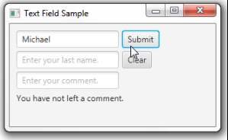
✔ Used to enter single line text
✅ Example:
import javafx.application.Application;
import javafx.stage.Stage;
import javafx.scene.Scene;
import javafx.scene.control.TextField;
import javafx.scene.layout.FlowPane;
public class A extends Application
{
public void start(Stage s)
{
TextField t = new TextField();
FlowPane f = new FlowPane();
f.getChildren().addAll(t);
Scene s1 = new Scene(f, 200, 250);
s.setScene(s1);
s.show();
}
}

5) TextArea:
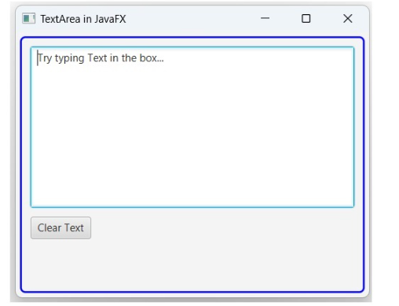

✔ Used to enter multiple lines (like address) import javafx.application.Application;
import javafx.stage.Stage;
import javafx.scene.Scene;
import javafx.scene.control.TextArea;
import javafx.scene.layout.FlowPane;
public class A extends Application
{
public void start(Stage s)
{
TextArea t = new TextArea();
FlowPane f = new FlowPane();
f.getChildren().addAll(t);
Scene s1 = new Scene(f, 200, 250);
s.setScene(s1);
s.show();
}
}

6) CheckBox:
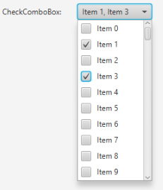
✔ Can be true (checked) or false (unchecked)
✔ User can select:
- One
- Multiple
- None
✅ Example:
import javafx.application.Application;
import javafx.stage.Stage;
import javafx.scene.Scene;
import javafx.scene.control.CheckBox;
import javafx.scene.layout.FlowPane;
public class A extends Application
{
public void start(Stage s)
{
CheckBox c1 = new CheckBox("Reading");
CheckBox c2 = new CheckBox("Dancing");
CheckBox c3 = new CheckBox("Singing");
FlowPane f = new FlowPane();
f.getChildren().addAll(c1, c2, c3);
Scene s1 = new Scene(f, 200, 250);
s.setScene(s1);
s.show();
}
}

7) RadioButton:

✔ Only one option can be selected
✔ Uses ToggleGroup
✅ Example:
import javafx.application.Application;
import javafx.stage.Stage;
import javafx.scene.Scene;
import javafx.scene.control.RadioButton;
import javafx.scene.layout.FlowPane;
import javafx.scene.control.ToggleGroup;
public class A extends Application
{
public void start(Stage s)
{
ToggleGroup t = new ToggleGroup();
RadioButton r1 = new RadioButton("Male");
r1.setToggleGroup(t);
RadioButton r2 = new RadioButton("Female");
r2.setToggleGroup(t);
FlowPane f = new FlowPane();
f.getChildren().addAll(r1, r2);
Scene s1 = new Scene(f, 200, 250);
s.setScene(s1);
s.show();
}
}

8) ComboBox:
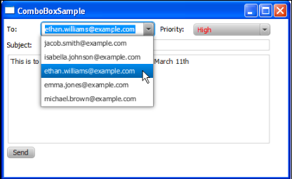
✔ Shows one item first, others appear on click
👉 Difference:
- ComboBox → show 1 item
- ListView → show all items
✅ Example:
import javafx.application.Application;
import javafx.stage.Stage;
import javafx.scene.Scene;
import javafx.scene.control.ComboBox;
import javafx.scene.layout.FlowPane;
import javafx.collections.FXCollections;
import javafx.collections.ObservableList;
public class A extends Application
{
public void start(Stage s)
{
ObservableList<String> items =
FXCollections.observableArrayList("M.B.A", "M.Sc.IT", "I.T");
ComboBox<String> c = new ComboBox<>(items);
FlowPane f = new FlowPane();
f.getChildren().addAll(c);
Scene s1 = new Scene(f, 200, 250);
s.setScene(s1);
s.show();
}
}

9) ListView:
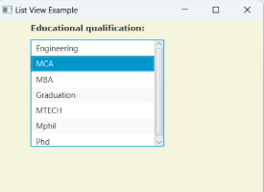
✔ Shows all items at once (scrollable list)
✅ Example:
import javafx.application.Application;
import javafx.stage.Stage;
import javafx.scene.Scene;
import javafx.scene.control.ListView;
import javafx.scene.layout.FlowPane;
import javafx.collections.FXCollections;
import javafx.collections.ObservableList;
public class A extends Application
{
public void start(Stage s)
{
ObservableList<String> items =
FXCollections.observableArrayList("M.B.A", "M.Sc.IT", "I.T");
ListView<String> l = new ListView<>(items);
FlowPane f = new FlowPane();
f.getChildren().addAll(l);
Scene s1 = new Scene(f, 200, 250);
s.setScene(s1);
s.show();
}
}

10) ProgressBar:
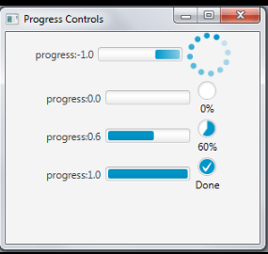
✔ Shows task completion (0 to 1)
✅ Example:
import javafx.application.Application;
import javafx.stage.Stage;
import javafx.scene.Scene;
import javafx.scene.control.ProgressBar;
import javafx.scene.control.ProgressIndicator;
import javafx.scene.layout.FlowPane;
public class A extends Application
{
public void start(Stage s)
{
ProgressBar p = new ProgressBar(0.6);
ProgressIndicator pi = new ProgressIndicator(0.6);
FlowPane f = new FlowPane();
f.getChildren().addAll(p, pi);
Scene s1 = new Scene(f, 200, 250);
s.setScene(s1);
s.show();
}
}

11) Slider
✔ Select value by sliding
✅ Example:
import javafx.application.Application;
import javafx.stage.Stage;
import javafx.scene.Scene;
import javafx.scene.control.Slider;
import javafx.scene.layout.FlowPane;
public class A extends Application
{
public void start(Stage s)
{
Slider sl = new Slider();
sl.setMin(0);
sl.setMax(100);
sl.setValue(50);
FlowPane f = new FlowPane();
f.getChildren().addAll(sl);
Scene s1 = new Scene(f, 200, 250);
s.setScene(s1);
s.show();
}
}

12) ColorPicker:
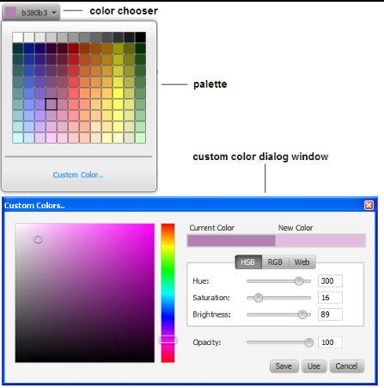
✔ Used to select a color
✅ Full Code:
import javafx.application.Application;
import javafx.stage.Stage;
import javafx.scene.Scene;
import javafx.scene.control.ColorPicker;
import javafx.scene.layout.FlowPane;
public class A extends Application
{
public void start(Stage s)
{
ColorPicker c = new ColorPicker();
FlowPane f = new FlowPane();
f.getChildren().addAll(c);
Scene s1 = new Scene(f, 200, 250);
s.setScene(s1);
s.show();
}
public static void main(String[] args)
{
launch(args);
}
}

13) DatePicker:
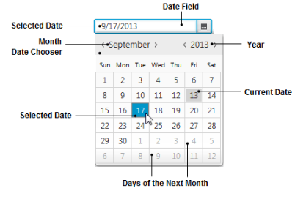
✔ Used to select date from calendar
✅ Full Code:
import javafx.application.Application;
import javafx.stage.Stage;
import javafx.scene.Scene;
import javafx.scene.control.DatePicker;
import javafx.scene.layout.FlowPane;
public class A extends Application
{
public void start(Stage s)
{
DatePicker d = new DatePicker();
FlowPane f = new FlowPane();
f.getChildren().addAll(d);
Scene s1 = new Scene(f, 200, 250);
s.setScene(s1);
s.show();
}
public static void main(String[] args)
{
launch(args);
}
}

14) ScrollBar:
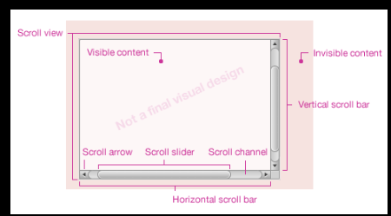
✔ Used to select value by scrolling
✅ Full Code:
import javafx.application.Application;
import javafx.stage.Stage;
import javafx.scene.Scene;
import javafx.scene.control.ScrollBar;
import javafx.scene.layout.FlowPane;
public class A extends Application
{
public void start(Stage s)
{
ScrollBar sb = new ScrollBar();
sb.setMin(0);
sb.setMax(100);
sb.setValue(50);
FlowPane f = new FlowPane();
f.getChildren().addAll(sb);
Scene s1 = new Scene(f, 200, 250);
s.setScene(s1);
s.show();
}
public static void main(String[] args)
{
launch(args);
}
}

15) PasswordField:
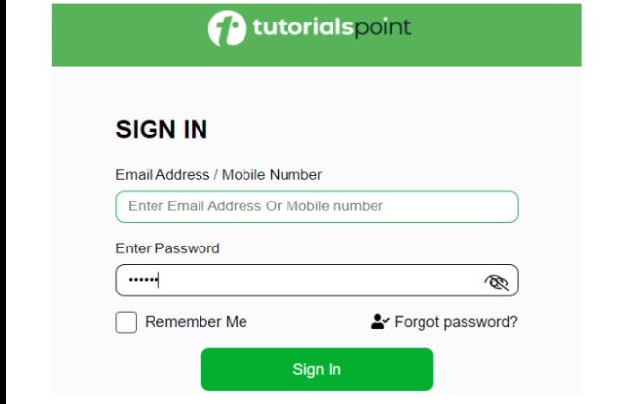

import javafx.application.Application;
import javafx.stage.Stage;
import javafx.scene.Scene;
import javafx.scene.control.PasswordField;
import javafx.scene.layout.FlowPane;
public class A extends Application
{
public void start(Stage s)
{
PasswordField p = new PasswordField();
FlowPane f = new FlowPane();
f.getChildren().addAll(p);
Scene s1 = new Scene(f, 200, 250);
s.setScene(s1);
s.show();
}
public static void main(String[] args)
{
launch(args);
}
}

🧠 Quick Memory Tip
👉 Last 4 controls:
- ColorPicker → color choose
- DatePicker → date choose
- ScrollBar → scroll value
- PasswordField → hidden text

🧠 FINAL MEMORY SHORTCUT
👉 Group them:
Text Input:
- TextField (single line)
- TextArea (multi line)
- PasswordField
Selection:
- CheckBox (multiple)
- RadioButton (single)
- ComboBox
- ListView
Display:
- Label
- ProgressBar
Advanced:
- Slider
- ColorPicker
- DatePicker
- ScrollBar

Shapes:

✅ JavaFX Shapes (Simple Understanding)
👉 Shapes are used to draw graphics like:
- Line
- Circle
- Rectangle
- Curve
- Polygon
👉 All shapes come from package:
javafx.scene.shape

- Line

✔ Line means straight line between two points
👉 Class: Line
👉 Methods:
- setStartX() → starting X
- setStartY() → starting Y
- setEndX() → ending X
- setEndY() → ending Y
✅ Example:
import javafx.application.Application;
import javafx.stage.Stage;
import javafx.scene.Scene;
import javafx.scene.shape.Line;
import javafx.scene.Group;
public class A extends Application
{
public void start(Stage s)
{
Line l = new Line();
l.setStartX(100.0);
l.setStartY(150.0);
l.setEndX(500.0);
l.setEndY(150.0);
Group g = new Group(l);
Scene s1 = new Scene(g, 200, 250);
s.setScene(s1);
s.show();
}
}

- Rectangle
✔ Rectangle = box shape
👉 Methods:
- setX() → position X
- setY() → position Y
- setWidth()
- setHeight()
✅ Example:

import javafx.application.Application;
import javafx.stage.Stage;
import javafx.scene.Scene;
import javafx.scene.shape.Rectangle;
import javafx.scene.Group;
public class A extends Application
{
public void start(Stage s)
{
Rectangle r = new Rectangle();
r.setX(150.0);
r.setY(75.0);
r.setWidth(400.0);
r.setHeight(150.0);
Group g = new Group(r);
Scene s1 = new Scene(g, 200, 250);
s.setScene(s1);
s.show();
}
}

- Rounded Rectangle
✔ Rectangle with round corners
👉 Extra methods:
- setArcWidth()
- setArcHeight()
✅ Example:
Rectangle r = new Rectangle();
r.setX(150.0);
r.setY(75.0);
r.setWidth(400.0);
r.setHeight(150.0);
r.setArcWidth(30.0);
r.setArcHeight(20.0);

- Circle
Circle = all points at equal distance from center
👉 Methods:
- setCenterX()
- setCenterY()
- setRadius()
✅ Example:
Circle c = new Circle();
c.setCenterX(300.0);
c.setCenterY(150.0);
c.setRadius(50.0);

- Ellipse
✔ Ellipse = oval shape
👉 Methods:
- setCenterX()
- setCenterY()
- setRadiusX()
- setRadiusY()
✅ Example:

Ellipse e = new Ellipse();
e.setCenterX(300.0);
e.setCenterY(150.0);
e.setRadiusX(150.0);
e.setRadiusY(75.0);

- Arc
✔ Arc = part of circle or ellipse
👉 Methods:
- setCenterX()
- setCenterY()
- setRadiusX()
- setRadiusY()
- setStartAngle()
- setLength()
✅ Example:
Arc a = new Arc();
a.setCenterX(400.0);
a.setCenterY(200.0);
a.setRadiusX(50.0);
a.setRadiusY(80.0);
a.setStartAngle(30.0);
a.setLength(70.0);

- PolyLine
✔ Same as polygon
❌ But NOT closed
👉 Method:
- getPoints().addAll()
✅ Example:

PolyLine p = new PolyLine();
p.getPoints().addAll(new Double[]{
200.0,200.0, 300.0,100.0, 400.0,200.0
});

- Polygon (JavaFX)
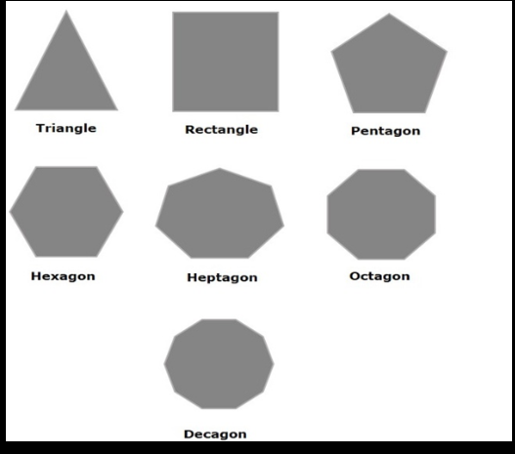

✔ Simple Meaning:
👉 Polygon = closed shape made using lines
👉 All lines are connected end to end
👉 Shape is closed (no open ends)

✔ Types of Polygon (based on sides)
👉 Number of sides → Name:
- sides → Triangle
- sides → Quadrilateral
(Rectangle, Square, Parallelogram)
- sides → Pentagon
- sides → Hexagon
- sides → Heptagon
- sides → Octagon

✔ JavaFX Polygon Class
👉 Class name:
Polygon

👉 Package:
javafx.scene.shape

✔ Important Method
👉 Polygon has only one main method:
getPoints().addAll(...)
👉 Used to add points (x, y)
👉 Each pair = one point
👉 Points automatically join → shape created

✔ Triangle Example (3 points)
import javafx.application.Application;
import javafx.stage.Stage;
import javafx.scene.Scene;
import javafx.scene.shape.Polygon;
import javafx.scene.Group;
public class A extends Application
{
public void start(Stage s)
{
Polygon p = new Polygon();
p.getPoints().addAll(
200.0, 200.0,
300.0, 100.0,
400.0, 200.0
);
Group g = new Group(p);
Scene s1 = new Scene(g, 200, 250);
s.setScene(s1);
s.show();
}
}

🧠 Easy Understanding Trick
👉 Think like dots:
(x1,y1) → (x2,y2) → (x3,y3) → back to start
✔ JavaFX automatically connects last point to first → makes closed shape

🔥 One-Line Exam Answer
👉 Polygon is a closed shape formed by connecting multiple points, and in JavaFX it is created using the Polygon class with getPoints().addAll() method.

✅ 🔺 Triangle (3 sides)
p.getPoints().addAll(
200.0, 200.0,
300.0, 100.0,
400.0, 200.0
);
✅ ◼ Rectangle (4 sides)
p.getPoints().addAll(
200.0, 100.0,
400.0, 100.0,
400.0, 300.0,
200.0, 300.0
);
✅ ⬟ Pentagon (5 sides)
p.getPoints().addAll(
300.0, 100.0,
400.0, 180.0,
360.0, 300.0,
240.0, 300.0,
200.0, 180.0
);
✅ ⬡ Hexagon (6 sides)
p.getPoints().addAll(
250.0, 100.0,
350.0, 100.0,
400.0, 200.0,
350.0, 300.0,
250.0, 300.0,
200.0, 200.0
);
✅ ⬢ Heptagon (7 sides)
p.getPoints().addAll(
300.0, 100.0,
380.0, 140.0,
400.0, 220.0,
350.0, 300.0,
250.0, 300.0,
200.0, 220.0,
220.0, 140.0
);
✅ ⬣ Octagon (8 sides)
p.getPoints().addAll(
260.0, 100.0,
340.0, 100.0,
400.0, 160.0,
400.0, 240.0,
340.0, 300.0,
260.0, 300.0,
200.0, 240.0,
200.0, 160.0
);
✅ Decagon (10 sides)
p.getPoints().addAll(
300.0, 100.0,
360.0, 120.0,
400.0, 180.0,
400.0, 240.0,
360.0, 300.0,
300.0, 320.0,
240.0, 300.0,
200.0, 240.0,
200.0, 180.0,
240.0, 120.0
);

🔹 5 MARK QUESTIONS
- Write program to draw:
  - Line
  - Rectangle
  - Circle
  - Polygon
👉 VERY HIGH CHANCE

Q-4: Color Class & Font Class
Ans:
🎨 Color Class

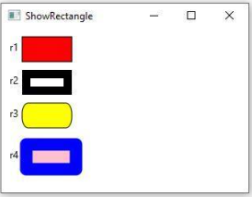

✔ Simple Meaning:
Color class is used to change the color of shapes, text, etc.
👉 By default:
- All shapes are black
👉 But JavaFX allows:
- You can change to any color (Red, Blue, Green, etc.)

- ✔ Package:
javafx.scene.paint

✔ Important Point:
- There is a base class called Paint
- Color class is a child of Paint

✔ Methods:
- setFill() → fill inside color
- setStroke() → border color

import javafx.application.Application;
import javafx.stage.Stage;
import javafx.scene.Scene;
import javafx.scene.shape.Circle;
import javafx.scene.Group;
import javafx.scene.paint.Color;
public class A extends Application
{
public void start(Stage s)
{
Circle c = new Circle();
c.setCenterX(300.0);
c.setCenterY(150.0);
c.setRadius(50.0);
c.setFill(Color.RED); // change color
Group g = new Group(c);
Scene s1 = new Scene(g, 200, 250);
s.setScene(s1);
s.show();
}
}

🔤 Font Class

Font class is used to change text style
👉 You can change:
- Font name (Arial, Calibri)
- Size
- Bold
- Italic

- ✔ Package:
javafx.scene.text

✔ Font is defined by:
- Name
- Weight (Bold, Normal)
- Posture (Italic, Regular)
- Size

✔ Classes used:
- Font
- FontWeight
- FontPosture

import javafx.application.Application;
import javafx.stage.Stage;
import javafx.scene.Scene;
import javafx.scene.layout.FlowPane;
import javafx.scene.text.Text;
import javafx.scene.text.Font;
import javafx.scene.text.FontWeight;
import javafx.scene.text.FontPosture;
public class A extends Application
{
public void start(Stage s)
{
Text t = new Text("Hello how are you");
Font f = Font.font("Calibri",
FontWeight.EXTRA_BOLD,
FontPosture.ITALIC,
10);
t.setFont(f);
FlowPane f1 = new FlowPane();
f1.getChildren().addAll(t);
Scene s1 = new Scene(f1, 200, 250);
s.setScene(s1);
s.show();
}
}

Q-5: Property Binding

🔗 Property Binding (Very Simple)

Simple Meaning:
Property binding means:
👉 One object is connected to another object
👉 If source changes → target changes automatically

✔ Key Terms:
- Source object → main value
- Target object → depends on source
👉 Example:
- If width changes → circle position also changes

✔ Real Example:
👉 Problem:
- Circle is not centered when window size changes
👉 Solution:
- Bind circle position with pane size

✔ Important Concept:
target.bind(source)

✅ Example:
import javafx.application.Application;
import javafx.scene.Scene;
import javafx.stage.Stage;
import javafx.scene.layout.Pane;
import javafx.scene.shape.Circle;
public class A extends Application
{
public void start(Stage s)
{
Circle c = new Circle();
Pane p = new Pane();
// Binding (auto update position)
c.centerXProperty().bind(p.widthProperty().divide(2));
c.centerYProperty().bind(p.heightProperty().divide(2));
c.setRadius(50.0);
p.getChildren().addAll(c);
Scene s1 = new Scene(p, 200, 250);
s.setScene(s1);
s.show();
}
}

🧠 FINAL MEMORY TRICK
👉 Color
- Used to change color
- setFill(), setStroke()
👉 Font
- Used to style text
- Font name + size + style
👉 Binding
- Connect 2 objects
- Auto update

Q-6: Image and ImageView Class
Ans:
✔ Simple Meaning:
- Image → used to load image file
- ImageView → used to display image on screen
👉 Flow:
Image → ImageView → Screen
✔ Important Points:
- First create Image
- Then pass it to ImageView
- You can resize image without changing quality

✔ Methods:
- setX() → position X
- setY() → position Y
- setFitWidth() → width
- setFitHeight() → height

✔ Package:
import javafx.scene.image.Image;
import javafx.scene.image.ImageView;

✅ Example:
import javafx.application.Application;
import javafx.scene.Scene;
import javafx.stage.Stage;
import javafx.scene.Group;
import javafx.scene.image.Image;
import javafx.scene.image.ImageView;
import java.io.FileInputStream;
public class A extends Application
{
public void start(Stage s) throws Exception
{
FileInputStream f = new FileInputStream("E:\\images\\1.jpg");
Image i = new Image(f);
ImageView v = new ImageView(i);
v.setX(200.0);
v.setY(150.0);
v.setFitWidth(400.0);
v.setFitHeight(300.0);
Group g = new Group(v);
Scene s1 = new Scene(g, 200, 250);
s.setScene(s1);
s.show();
}
}

Q-7: Event Handling in JavaFX
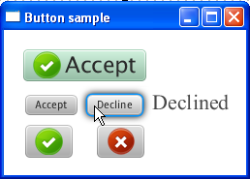

✔ Simple Meaning:
Event = user action
👉 Examples:
- Button click
- Mouse click
- Key press

✔ Package:

import javafx.event.Event;
import javafx.event.EventHandler;

✔ Types of Events:
1) Foreground Events
✔ Need user action
👉 Example: Button click
2) Background Events
✔ No user action
👉 Example: System process

✔ Event Components:
- Event Source → where event happens (Button)
- Event Target → where handled (Scene)
- Event Type → type (click, press)

🔄 Event Flow
1) Route Construction
✔ Path created from Stage → Node
2) Capturing Phase
✔ Event goes top → bottom
3) Bubbling Phase
✔ Event goes bottom → top

✔ Event Handler:
✔ Code that runs when event happens

🔹 Action Event (Button Click)
✔ Used for:
- Button click
✅ Example:
import javafx.application.Application;
import javafx.scene.Scene;
import javafx.stage.Stage;
import javafx.scene.control.Button;
import javafx.scene.layout.GridPane;
import javafx.event.ActionEvent;
import javafx.event.EventHandler;
import javafx.scene.control.Label;
public class A extends Application
{
public void start(Stage s)
{
Button b = new Button("Ok");
Label l = new Label();
GridPane g = new GridPane();
EventHandler<ActionEvent> e = new EventHandler<ActionEvent>()
{
public void handle(ActionEvent e1)
{
l.setText("Hello");
}
};
b.setOnAction(e);
g.addRow(0, b);
g.addRow(1, l);
Scene s1 = new Scene(g, 200, 250);
s.setScene(s1);
s.show();
}
}

🔹 Mouse Event
✔ Triggered by mouse
👉 Methods:
- setOnMousePressed
- setOnMouseReleased
- setOnMouseClicked
- setOnMouseEntered
- setOnMouseExited
- setOnMouseDragged

✅ Example:

import javafx.application.Application;
import javafx.scene.Scene;
import javafx.stage.Stage;
import javafx.scene.layout.GridPane;
import javafx.scene.control.Label;
import javafx.scene.input.MouseEvent;
public class A extends Application
{
public void start(Stage s)
{
Label l = new Label();
GridPane g = new GridPane();
g.getChildren().addAll(l);
Scene s1 = new Scene(g, 200, 250);
s1.setOnMousePressed(e -> l.setText("Mouse Pressed"));
s1.setOnMouseReleased(e -> l.setText("Mouse Released"));
s1.setOnMouseClicked(e -> l.setText("Mouse Clicked"));
s1.setOnMouseEntered(e -> l.setText("Mouse Entered"));
s1.setOnMouseExited(e -> l.setText("Mouse Exited"));
s1.setOnMouseDragged(e -> l.setText("Mouse Dragged"));
s.setScene(s1);
s.show();
}
}

🔹 Key Event
✔ Triggered by keyboard
👉 Methods:
- setOnKeyPressed
- setOnKeyReleased
- setOnKeyTyped

✅ Example: import javafx.application.Application;
import javafx.scene.Scene;
import javafx.stage.Stage;
import javafx.scene.layout.GridPane;
import javafx.scene.control.Label;
public class A extends Application
{
public void start(Stage s)
{
Label l = new Label();
GridPane g = new GridPane();
g.getChildren().addAll(l);
Scene s1 = new Scene(g, 200, 250);
s1.setOnKeyPressed(e -> l.setText("Key Pressed"));
s1.setOnKeyReleased(e -> l.setText("Key Released"));
s1.setOnKeyTyped(e -> l.setText("Key Typed"));
s.setScene(s1);
s.show();
}
}

Q-8: Nested and Inner Classes
✔ Simple Meaning:
Class inside another class

✔ Types:
- Static Nested Class
✔ No access to outer class variables
- Non-static Inner Class
✔ Can access all outer class variables
- Local Class
✔ Defined inside method
- Anonymous Class
✔ No name, used directly

✅ Anonymous Example:
b.setOnAction(new EventHandler<ActionEvent>()
{
public void handle(ActionEvent e)
{
System.out.println("button clicked");
}
});

✅ Q-9: Animation

✔ Simple Meaning:
Animation = moving or changing object over time
👉 Package:
javafx.animation

✔ Simple Meaning:
Animation means adding movement or effects to objects like:
- Text
- Images
- Shapes
👉 Example:
- Fade in/out
- Move object
- Change color
- Rotate

🔹 1) FadeTransition
✔ Used to change visibility (opacity)
👉 Example: fade in / fade out
✅ Example:
import javafx.application.Application;
import javafx.scene.Scene;
import javafx.stage.Stage;
import javafx.scene.layout.FlowPane;
import javafx.scene.shape.Circle;
import javafx.animation.FadeTransition;
import javafx.scene.paint.Color;
import javafx.util.Duration;
public class A extends Application
{
public void start(Stage s)
{
Circle c = new Circle();
c.setRadius(50.0);
c.setFill(Color.RED);
FlowPane f = new FlowPane();
FadeTransition f1 = new FadeTransition(Duration.millis(1000));
f1.setNode(c);
f1.setFromValue(1.0);
f1.setToValue(0.3);
f1.setCycleCount(50);
f1.setAutoReverse(false);
f1.play();
f.getChildren().addAll(c);
Scene s1 = new Scene(f, 200, 250);
s.setScene(s1);
s.show();
}
}

2) FillTransition
✔ Used to change color
👉 Example: Blue → Green
✅ Example:
import javafx.animation.FillTransition;
FillTransition f1 = new FillTransition(Duration.millis(1000));
f1.setShape(c);
f1.setFromValue(Color.BLUE);
f1.setToValue(Color.GREEN);
f1.setCycleCount(50);
f1.setAutoReverse(false);
f1.play();

3) RotateTransition
✔ Used to rotate object
✅ Example:

import javafx.animation.RotateTransition;
RotateTransition f1 = new RotateTransition(Duration.millis(1000));
f1.setNode(p);
f1.setByAngle(360);
f1.setCycleCount(50);
f1.setAutoReverse(false);
f1.play();

4) ScaleTransition
✔ Used to increase or decrease size
✅ Example:

import javafx.animation.ScaleTransition;
ScaleTransition f1 = new ScaleTransition(Duration.millis(1000));
f1.setNode(c);
f1.setByX(3.5);
f1.setByY(3.5);
f1.setCycleCount(50);
f1.setAutoReverse(false);
f1.play();

5) StrokeTransition
✔ Used to change border color
✅ Example:
import javafx.animation.StrokeTransition;
StrokeTransition f1 = new StrokeTransition(Duration.millis(1000));
f1.setShape(c);
f1.setFromValue(Color.BLACK);
f1.setToValue(Color.GREEN);
f1.setCycleCount(50);
f1.setAutoReverse(true);
f1.play();

🔹 6) TranslateTransition
✔ Used to move object
✅ Example:

import javafx.animation.TranslateTransition;
TranslateTransition f1 = new TranslateTransition(Duration.millis(1000));
f1.setNode(c);
f1.setByX(600.0);
f1.setCycleCount(50);
f1.setAutoReverse(false);
f1.play();

🔹 7) SequentialTransition
✔ Run animations one after another
✅ Example:
SequentialTransition st = new SequentialTransition(c, ft, f1);
st.play();

🔹 8) PauseTransition
✔ Used to pause animation
✅ Example:

PauseTransition pt = new PauseTransition();
pt.setDuration(Duration.millis(1000));

🔹 9) ParallelTransition
✔ Run animations together at same time
✅ Example:
ParallelTransition st = new ParallelTransition(c, ft, f1);
st.play();

Q-10 Write a short note on Video and Audio or Multimedia
Ans:
Multimedia means playing video and audio in JavaFX
👉 JavaFX gives special classes to:
- Load media
- Control media
- Show media

✅ Main Classes
1) Media
✔ Represents media file (video or audio)
✔ Used to load file

2) MediaPlayer
✔ Used to control media
👉 It can:
- Play
- Pause
- Stop
- Control volume
- Set speed
- Loop video

3) MediaView
✔ Used to display video on screen

4) AudioClip (extra)
✔ Used for simple sound effects

🔁 Flow (Very Important)
File → Media → MediaPlayer → MediaView → Screen

✅ Important Conversion Methods
👉 These are used to convert file path:
- m.toURI() → convert file to URI
- .toURL() → convert URI to URL
- .toString() → convert URL to String
👉 JavaFX needs String format path

✅ Example (Corrected + Simple)
import javafx.application.Application;
import javafx.scene.Scene;
import javafx.stage.Stage;
import javafx.scene.layout.FlowPane;
import javafx.scene.media.Media;
import javafx.scene.media.MediaPlayer;
import javafx.scene.media.MediaView;
import java.io.File;
public class A extends Application
{
public void start(Stage s)
{
File m = new File("C:/Users/HP/Downloads/2.mp4");
Media m1 = new Media(m.toURI().toString());
MediaPlayer m2 = new MediaPlayer(m1);
MediaView mv = new MediaView(m2);
FlowPane f = new FlowPane();
f.getChildren().addAll(mv);
Scene s1 = new Scene(f, 400, 300);
s.setScene(s1);
s.show();
m2.play(); // start video
}
}

🧠 FINAL MEMORY TRICK
👉 Remember like this:
- Media = file
- MediaPlayer = control
- MediaView = display
👉 Flow:
Media → MediaPlayer → MediaView
👉 Extra:
- AudioClip → sound only

Q-11 Write a short note on Listener for observable object
Ans:
✔ Simple Meaning:
👉 Listener = a watcher
✔ It watches a value
✔ When value changes → it automatically runs code

✔ Observable Object:
👉 Observable means value that can change
👉 Examples:
- StringProperty
- IntegerProperty
- BooleanProperty
✔ These values can be observed (tracked)

✅ ChangeListener
✔ Used to detect change in ONE value
👉 When value changes → method runs

✔ Method:
void changed(ObservableValue<? extends T> observable, T oldValue, T newValue);
👉 Meaning:
- observable → the value being watched
- oldValue → previous value
- newValue → new value

✅ Why we use Listener?
👉 To automatically respond when value changes
✔ Example:
- Value changes → print message
- Slider changes → update label
- Text changes → validate input

✅ Example (Simple + Clear)
import javafx.application.Application;
import javafx.scene.Scene;
import javafx.stage.Stage;
import javafx.scene.layout.FlowPane;
import javafx.beans.value.ChangeListener;
import javafx.beans.value.ObservableValue;
import javafx.beans.property.IntegerProperty;
import javafx.beans.property.SimpleIntegerProperty;
public class A extends Application
{
public void start(Stage s)
{
// create observable value
IntegerProperty n = new SimpleIntegerProperty(10);
// add listener
n.addListener(new ChangeListener<Number>()
{
public void changed(ObservableValue<? extends Number> observable,
Number oldValue,
Number newValue)
{
System.out.println("Old value: " + oldValue +
", New value: " + newValue);
}
});
// change value (this will trigger listener)
n.set(20);
FlowPane f = new FlowPane();
Scene s1 = new Scene(f, 200, 250);
s.setScene(s1);
s.show();
}
}

🧠 Step-by-Step Flow
- Create value → n = 10
- Add listener
- Change value → n.set(20)
- Listener runs automatically

🧠 FINAL MEMORY TRICK
👉 Listener = watcher
👉 Observable = changeable value
👉 When value changes:
Old value → New value → Listener runs

🔥 One-Line Exam Answer:
👉 Listener is used to detect and respond automatically when observable value changes

